Plate Tectonics Study Guide (Use the back or another page for more room) Name ______________________

1. What are the layers of the earth? Draw a diagram to illustrate.
Crust , Upper Mantle (these two make up the Lithosphere), Aesthenosphere, Lower Mantle, Outer Core, and Inner Core

2. Describe the composition of each layer and any special properties they have.

Crust – Oceanic (Basalt) and Continental (Granite)
Mantle – Convection Currents using the plasticity property
Core – Outer is liquid and the Inner is solid iron and nickel

3. What are convection currents and where are they found?
The convection currents are what plates float on and move. They are found in the middle mantle or Aesthenosphere
When magma from the outer core rises it causes the convection currents.

4. What causes the movement of Earth’s tectonic plates?
The convection currents

5. Define plasticity. What layer of the earth exhibits this trait?
Plasticity which is being in a thick liquid state, like asphalt. It is found in the Aesthenosphere.

6. How do scientists map the deep interior of the earth?

Using seismic waves

7. What happens to temperature, pressure and density as you go deeper into the earth?
They increase

8. The two types of tectonic plates are convergent and divergent.

9. How does new oceanic crust form? Cooling of magma

10. The place where two lithospheric plates meet is called a plate boundary.

11. What are the three types of boundaries and how do they form? Draw a diagram and label it.
Divergent- when 2 plates move away from each other
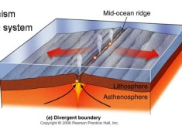

Convergent – when 2 plates move toward each other

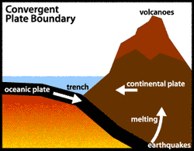

Transform – when 2 plates slide against each other

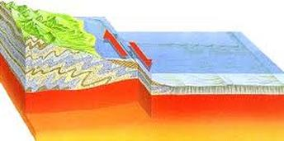

12. Where does sea-floor spreading take place? Where two oceanic plates meet that are divergent

13. What type of boundary is found at the mid-ocean ridges? Diverge
Where are the oldest rocks here? Farthest away from the boundary

14. Which boundary is associated with earthquakes? Transform

15. What happens at convergent boundaries? The plates move toward each other causing an uplift or mountains or a subduction resulting in a trench.

16. What is a subduction zone and where do they occur?
When two convergent boundaries meet one plate may be more dense than the other and will slide under the other plate. A good example is Oceanic-Continental boundaries.

17. What evidence did Wegner use to explain CONTINENTAL DRIFT? (essay and test)

Continents appear to fit like pieces of a puzzle
Geological structures are similar – Mountains in Eastern U.S. and Northern Europe
Fossils of the same organism are found on different continents
Climate change - Bituminous coal in Antarctica. The coal is from decayed ferns which require a tropical environment

18. Why did most geologists reject Alfred Wegener’s idea of continental drift? (essay and test)
They did not know about plate tectonics at the time. 30 years later sonar was able to be used to verify that the plates did in fact move.

