Earthquakes and Volcanoes Study Guide 2013 Name __________
- What is stress in terms of plate boundaries?
The amount of force per unit area on a given material
2. Fill out the following chart:
Stress | Definition | Fault | Boundary | Letter with arrows
shearing | A stress that moves a mass of rock in two opposite horizontal directions | Strike-slip | transform
tension | A stress that pulls or stretches the crust | normal | divergent
compression | A stress that squeezes the crust | reverse | convergent
3. Name and define the three types of plate boundaries.
1. Convergent – two plates pushing together - colliding
2. Divergent – two plates pull apart - divide
3. Transform – two plates slide past each other - sliding
4. A fault is a break in the earth’s crust along which blocks of crust slide relative to one another.
5. Most earthquakes occur along the edges of (tectonic) plate boundaries.
6. What are seismic waves? How do we measure them?
Seismic waves are the waves of energy from an earthquake that travel through Earth. We measure them with a seismograph.
7. Why do we have more earthquakes on the west coast than the east coast of the US?
The west coast has the plate boundary of the Pacific Plate and the North American Plate.
8. We do not have a lot of earthquakes or volcanoes in Georgia because we are not on a plate boundary.
9. The focus and the epicenter are related by the epicenter being on the surface directly above the focus, which is the beginning of the fault and, therefore, the earthquake.
10. What are the differences between p-waves, s-waves and surface waves? What do the “p” and “s” stand for? P-waves are primary waves and can travel through solids, liquids and gasses; they are the fastest waves. They squeeze and stretch. S-waves are secondary waves. They are slower and only travel through solids in a side-to-side motion. P and S waves are body waves. Surface waves do the most damage because they are rolling waves on the surface and travel the slowest.
11. Surface waves are the seismic waves that do the most damage.
12. Fill in the following chart:
*Type of volcano | Description | Picture | How it forms
Composite | Neither steep nor gentle sides | 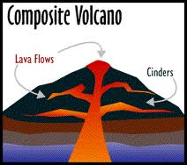 | *A combination of explosive and non-explosive eruptions
Shield | *Gently sloping sides | 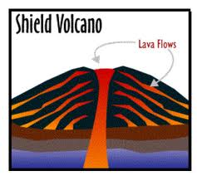 | Non-explosive; lava quickly and gently flow in a constant way
Cinder Cone | *Steep sides | 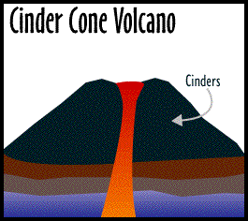 | Pyroclastic material from explosive eruptions
13. Describe how and where subduction occurs. Why does it happen? Subduction is the movement of one tectonic plate underneath another at convergent boundaries. Oceanic plates can subduct under other oceanic plates or continental plates because oceanic plates are DENSER than continental plates.
14. Describe the differences between an active, a dormant and an extinct volcano.
An active volcano is “live” and could erupt at any time or is currently erupting. A dormant volcano (sleeping) could erupt, but it is not likely to any time soon. An extinct volcano is dead and not likely to ever erupt again.
15. Most volcanoes occur along major plate boundaries. (NOT JUST THE RING OF FIRE!!!)
16. A hot spot is a site where the magma pushes or burns through a thinner spot in the crust. Do we have one in the US? Yes – the Hawaiian Islands – NOT PART OF THE RING OF FIRE!!
17. What is the Mid-Atlantic Ridge? It is a divergent boundary on the floor of the Atlantic Ocean that creates an underwater mountain chain running the length of the Atlantic Ocean.
Why is there volcanic activity there? It is a divergent boundary – a mid-ocean ridge where magma is continuously near the surface as new crust is being formed.
18. The Ring of Fire is the major volcanic belt that surrounds the Pacific Ocean.
19. If you feel earthquakes near an active volcano, RUN!!!! There is about to be an eruption.

