Ötzi the Iceman suffered a serious brain injury before he died, scientists say

Protein analysis helps scientists learn more clues about the mummy, which was discovered in the Alps in 1991.

BY DAVID BOROFF / NEW YORK DAILY NEWS

TUESDAY, JUNE 11, 2013, 1:02 PM
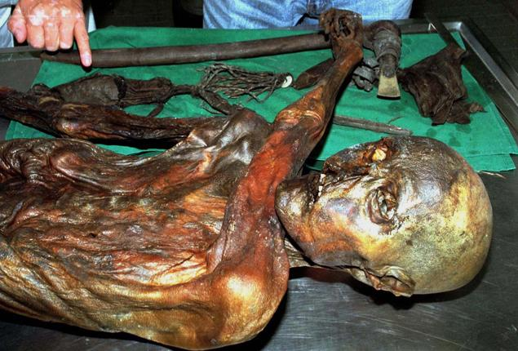

WERNER NOSKO/REUTERS

Ötzi the Iceman was pierced with an arrow and suffered a brain injury before he died. New research indicates that wasn't his only ailment.
One of the world's most famous mummies likely died with a massive headache.
Ötzi the Iceman, whose preserved body was found in the Alps in 1991, suffered a serious head injury before he died more than 5,000 years ago, new research shows.
Scientists who examined tiny brain tissue surmised that Ötzi had bruising in his brain before his death. Dark spots had been found in the back of Ötzi's head as early as 2007, but Monday's announcement proved to be a major breakthrough in trying to determine the cause of the Iceman's death.
"When you think that we have succeeded in identifying actual tissue changes in a human who lived over 5,000 years ago, you can begin to understand how pleased we are as scientists that we persisted with our research after many unsuccessful attempts," said Frank Maixner, who contributed to the study published in the journal Cellular and Molecular Life Sciences. "It has definitely proved worthwhile!"
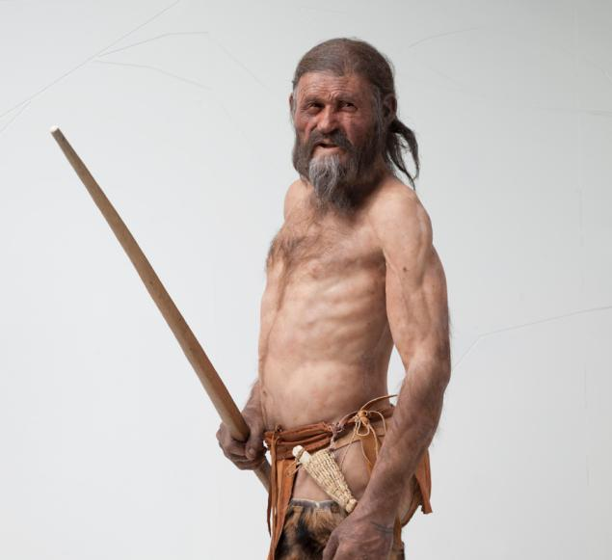

SOUTH TYROL MUSEUM OF ARCHAEOLOGY

A reconstruction of what Ötzi might have looked like.
However, researchers still have a long way to go as Ötzi's exact cause of death remains a mystery.
Scientists believe he was also struck in the shoulder with an arrow before he died. He had undigested food in his stomach, suggesting an ambush. It is unknown whether Ötzi was hit in the head or whether he fell on it after he was pierced with the arrow.
Modern analysis of proteins is responsible for the breakthrough in such a difficult case, scientists say.
"Proteins are the decisive players in tissues and cells, and they conduct most of the processes which take place in cells," scientist Andreas Tholey said in the statement. "Identification of the proteins is therefore key to understanding the functional potential of a particular tissue."
Read more: http://www.nydailynews.com/life-style/health/214-tzi-iceman-suffered-brain-injury-died-scientists-article-1.1369243#ixzz2e4baAE6s

http://archaeology.about.com/od/iterms/qt/iceman.htm
http://science.howstuffworks.com/environmental/earth/geology/la-brea-tar-pits.htm
http://science.howstuffworks.com/environmental/earth/geology/fossil.htm

